Ready, Set, EDDIE!

# Tips & tricks for teaching the Macrosystems EDDIE: Teleconnections

To download module files, teaching guides, and other course materials, please visit: <http://module3.macrosystemseddie.org>.

# Part 1: R your computers ready?

The Macrosystems EDDIE module is run using R, an open source software program for statistics and graphing.

Making sure R is installed and up-to-date on student computers before you begin teaching the module will help keep students focused on the ecology learning goals, and minimize time spent diagnosing and troubleshooting compatibility problems on computers.

If students will be completing the module on personal laptops, we recommend having them work through the “R You Ready for EDDIE” file in advance (also available from the SERC website above), so they come to class prepared to run the module. The file includes detailed directions for students to:

## Download and install R and RStudio

## Install packages used in the EDDIE module

## Download and unzip the Macrosystems EDDIE module files

As well as additional troubleshooting steps for Mac users, depending on their operating system.

# Part 2: Background on the GLM and associated files

This Macrosystems EDDIE module utilizes the General Lake Model (GLM), which was first developed by researchers at the University of Western Australia, in collaboration with members of the Global Lake Ecological Observatory Network (GLEON; Hipsey et al. 2014).

## Model Structure

The GLM is a one-dimensional hydrodynamic model, meaning that the lake is divided into vertical “slices”, and within each slice, conditions are the same across the lake (horizontally). The GLM model simulates physical characteristics of the lake, including water temperature and water density, by modeling energy within each layer, and vertical mixing between layers. The model simulates the lake water balance by accounting for inflows and outflows from the lake, if specified; otherwise the water balance is constant over time.

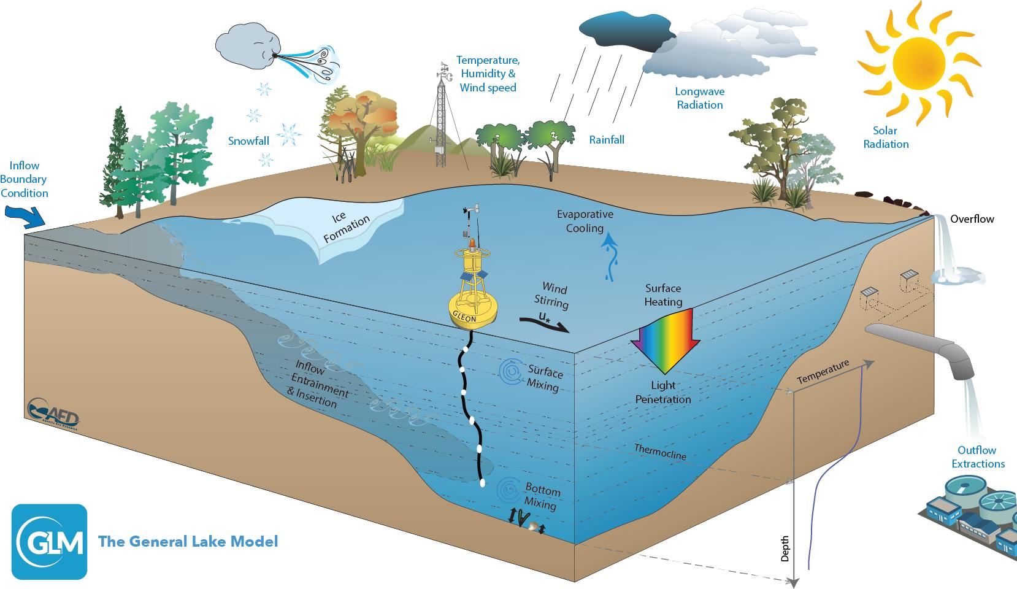

*Schematic of GLM model: Figure 1 from Hipsey et al. (2014).*

Users can run the GLM model using the R statistical interface through the “GLMr” package (Hipsey et al. 2014). Output from the GLM can be plotted and further manipulated in R using the “glmtools” package (Read et al. 2014).

The GLM can also be coupled with water quality models, including the Framework for Aquatic Biogeochemical Models (FABM) and the Aquatic EcoDynamics (AED; Hipsey et al. 2014) to simulate coupled physical and biological, and chemical processes in lakes.

For the Macrosystems EDDIE Teleconnections module, students will run the GLM model a lake from a list of available lakes.

## File Types in GLM

There are several files that are required to run GLM. These files have been compiled as a .zip file for the Macrosystems EDDIE module, to streamline the modeling process. Here, we provide a brief overview of the file types used in the model.

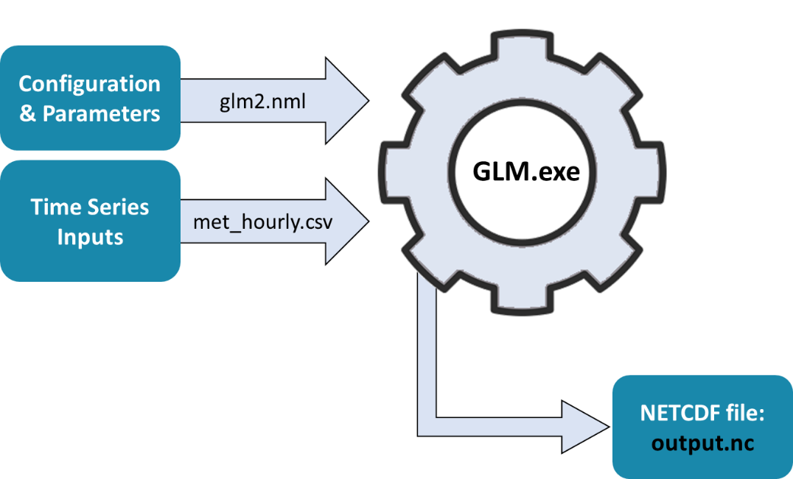

*Simplified diagram of GLM input and output files used in the Macrosystems EDDIE module. Modified from Hipsey et al. (2014).*

### Model Inputs:

* **glm2.nml**: This file (the “.nml file”) provides details of the overall model configuration, via many different model parameters that can be specified, or use default values.
  + These parameters include information on lake morphometry, meteorology, lake inflows and outflows, and information about the timing of the model simulation.
  + The .nml file can be opened and changed directly through RStudio by clicking on the file name, or using a text editor (e.g., Notepad on Windows or TextEdit on Mac).
  + In the .nml file, lines that begin with an exclamation point (!) are not read by the program, and are used to annotate the file.
  + **Important note**: The .nml file must *always* be named glm2.nml in order to run correctly in the current version of the GLM model.
  + In addition, if you edit certain values in the .nml file, check that quotation marks are straight up down vs. curved: e.g., sim_name = 'Awesome Lake' is correct; sim_name = ‘Awesome Lake’ is not.
* **met_hourly.csv**: This file contains a time series of meteorological (“met”) data used to drive the GLM model. Specifically, this file provides hourly values of shortwave and longwave radiation, air temperature, relative humidity, wind speed, rain, and snow. Students will manipulate the AirTemp column in this file when creating their El Niño scenarios.
* **inflow.csv:** This file (if applicable to a specific lake) contains a time series of the water volume flowing into the lake, as well as physical and chemical variables that describe the inflowing water. In this module, the inflow driver file includes flow volume (FLOW), salt concentration (SALT), and water temperature (TEMP).
* **outflow.csv:** This file (if applicable to a specific lake) contains a time series of outflow volume from the lake.

### Model Outputs:

* **output.nc**: This file contains the hourly output of the GLM model simulation that is created after you run the model, and includes water temperature and density of each vertical layer. The output time series can be used to produce heatmaps of water temperature for the lake profile over time (see example below).

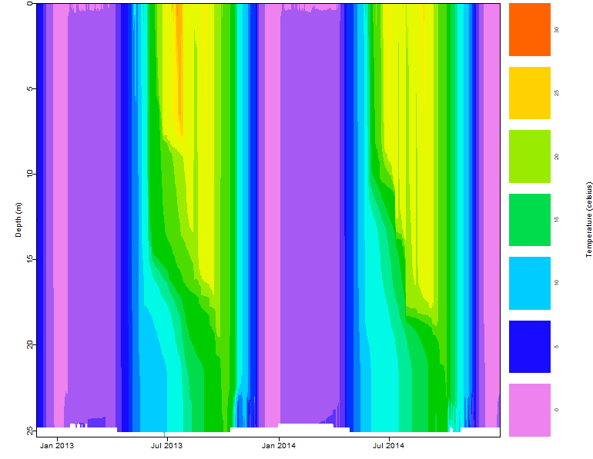

*Example heat map produced from Macrosystems EDDIE module showing Lake Mendota water temperatures across water depths and over time.*

# References and Additional Resources

## GLM model documentation:

Hipsey, M. R., L. C. Bruce, and D. P. Hamilton. 2014. GLM - General Lake Model: Model overview and user information. AED Report #26, University of W. Australia, Perth, Australia. 42 pp.

## Select recent publications that have used GLM:

Fenocchi, A., M. Rogora, S. Sibilla, and C. Dresti. 2017. Relevance of inflows on the thermodynamic structure and on the modeling of a deep subalpine lake (Lake Maggiore, Northern Italy/Southern Switzerland). Limnologica 63:42–56.

Read, J. S., L. A. Winslow, G. J. A. Hansen, J. Van Den Hoek, P. C. Hanson, L. C. Bruce, and C. D. Markfort. 2014. Simulating 2368 temperate lakes reveals weak coherence in stratification phenology. Ecological Modelling 291:142–150.